GIVE ME TO A FRIEND
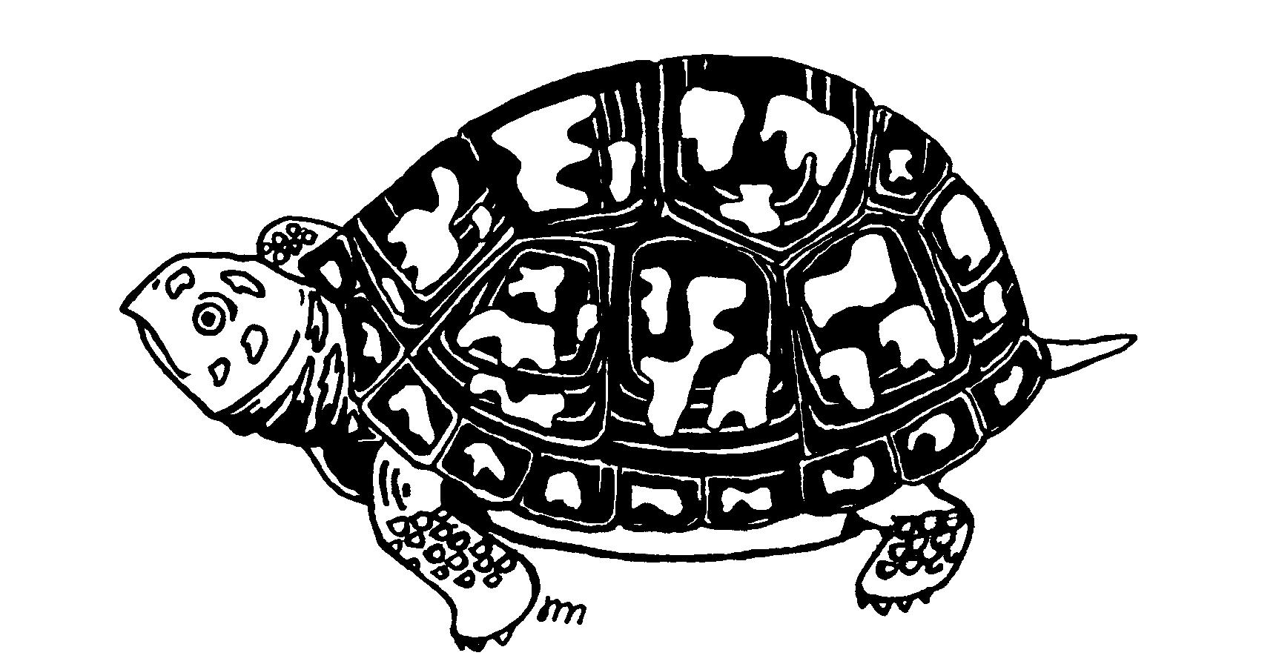

The Turtle and Tortoise Society of Charleston is a non-profit 501(c) (3) organization dedicated to promotion of proper husbandry and education about all turtles and tortoises. We encourage the dissemination of information, which will aid other members in establishing and maintaining habitats, which will ensure the health and growth of captive turtle populations. Whether your collection consists of many varieties exotic turtles or a single common turtle, membership will ensure that you will have access to a variety of written information and shared experiences which will help you keep your turtles and tortoises healthy and happy. The Turtle & Tortoise Society also is actively pursuing conservation measures that will help in protecting wild turtle populations which includes a rescue and rehabilitation program for injured and neglected turtles. The Turtle & Tortoise Society sponsors many activities including field trips and workshops on turtle care. Membership in the Society benefits both the turtle owner and the turtle.

Membership Application

Name

Address

City State Zip

Phone Numbers (Home) (Work)

Special Talents

Turtles in collection

I am interested in: Rehab Work Conservation Other
Membership Classification: Family ($12.00) Individual ($10.00)
The TTSC is a non-profit 501(c) (3) organization. Contributions are tax deductible to the full extent of the law.

Mail Check to: TTSC, P.O. Box 687, Ladson, SC 29456, (843)871-6606
INTERNET: HTTP://WWW.TURTLESANCTUM.ORG/

